Employee Payroll Management System

Cornerstone project work submitted to Aditya University in partial fulfilment of the requirements for the award of the Degree of

B.Tech. degree in
Artificial Intelligence & Machine Learning (2026-2027)

HARSHITH SAILA | 25B11AIB60
CH DEVI SRI PRASAD | 25B11AI230
INNAMURI KARTHIK | 25B11AI045
P.BHARATH MAHESH | 25B11AI963
SUBMITTED BY

UNDER THE GUIDANCE OF
T.VIJAYALAKSHMI
Assistant Professor
Department of AIML

DEPARTMENT OF ARTIFICIAL INTELLIGENCE & MACHINE LEARNING
ADITYA UNIVERSITY, ADITYA NAGAR,ABD ROAD,
SURAMPALEM

This is to certify that the cornerstone project entitled “EMPLOYEE PAYROLL MANAGEMENT SYSTEM” is being submitted by Saila Harshith (25B11AIB60), Chitturi Devi Sri Prasad (25B11AI230), Pithani Bharath Mahesh (25B11AI963), and Innamuri Karthik (26B21AI045), in partial fulfilment for the award of B. Tech Degree from Aditya University, is a record of original work done by them under my supervision. The contents of this project, in full or in parts, have not been submitted to any other Institute or University for the award of any degree or diploma.

Project Guide  T.Vijaya Lakshmi  Assistant Professor  Department of AIML | Head of the Department  Dr. K.Naga Bhargavi, M.Tech, Ph.D  Associate Professor  Department of AIML

DECLARATION

I hereby declare that the Cornerstone project work entitled “EMPLOYEE PAYROLL MANAGEMENT SYSTEM” is being submitted by me for the award of the B. Tech Degree in Computer Science and Engineering, Aditya University, Aditya Nagar, ADB Road, Surampalem is a record of original work carried out by us. We further declare that this project work has not been submitted, either in full or in part, for the award of any degree or diploma in this or any other institution. We also confirm that this work has been carried out with academic honesty and complies with the Institutional Academic Integrity and AI Usage Policy.

Project Associates
HARSHITH SAILA | 25B11AIB60
CH DEVI SRI PRASAD | 25B11AI230
INNUMURI KARTHIK | 26B21AI045
P.BHARATH MAHESH | 25B11AI963

Place:
Date:

ACKNOWLEDGEMENT
It is with immense pleasure that we express our sincere gratitude to our Cornerstone Project Guide, Ms. T VijayaLakshmi, Assistant Professor, who has guided us throughout the project. Her valuable support, encouragement, and guidance have greatly contributed to the successful completion of this work.

We would like to thank our Deputy Heads of the Department, Dr. R. Suneetha, Assistant Professor, Dr.Bollu Manikyala Rao, Associate Professor ,Dr.D.Veeraswamy,Assistant Professor Department of AIML, for their support and valuable suggestions.

Our deepest thanks to our Head of the Department Dr. . K.Naga Bhargavi, Associate Professor,
for her inspiration and for providing all the necessary facilities and resources required for this project.
We also extend our sincere thanks to Dr. M.V. Rajesh, Associate Dean, School of Computing for their encouragement and support during the course of our project.

We would like to express our sincere gratitude to Dr. G. Suresh, Registrar, Dr. A Ramesh, Pro Vice-Chancellor (Engineering & Sciences), Dr.S. Rama Sree, Pro Vice-Chancellor (Academics), D r . M.B. Srinivas, V i c e -Chancellor, Dr. M. Sreenivasa Reddy, Deputy Pro Chancellor and Management, Aditya University for providing excellent infrastructure and state-of-the-art laboratories.

Finally, we would like to thank the faculty members, lab technicians, non-teaching staff, and our friends who have directly or indirectly supported us in completing this Cornerstone project successfully.

Project Associates
Saila Harshith
CH Devi Sri Prasad
Innamuri Karthik
Pithani Bharath Mahesh

Date:

ABSTRACT

The Employee Payroll Management System is a menu-driven C++ application developed to organise employee information and support basic payroll activities. Payroll management includes maintaining employee details, recording attendance-related information, calculating salary components, and presenting salary information in a clear format. Performing these tasks manually may require repeated calculations and can make it difficult to find or update a particular employee record.
The application stores details such as Employee ID, name, department, basic salary, allowance, bonus, deduction, working hours, and leave status. It provides options to add, display, search, update, and delete employee records. Additional functions support attendance management, salary management, payroll processing, salary-slip generation, and report generation.
The system uses the Employee class to group data members and member functions. An array of objects is used to manage multiple employee records during program execution. Employee IDs help locate the intended record for search, update, and delete operations. Gross salary is calculated as the sum of basic salary, allowance, and bonus. Net salary is calculated by subtracting deduction from gross salary.
The project demonstrates practical use of Object-Oriented Programming concepts, including classes, objects, constructors, encapsulation, member functions, arrays, loops, and conditional statements. The current implementation is a console-based prototype and stores data in memory only while the program is running. File handling, database integration, access control, and advanced salary rules are possible future improvements.
Keywords: Employee Payroll Management System, C++, Object-Oriented Programming, Employee Records, Attendance, Salary Calculation, Payroll Processing, Salary Slip.

ABBREVATIONS

Abbreviation | Full Form / Meaning
OOP | Object-Oriented Programming
ID | Identifier
C++ | General-purpose programming language used for implementation
I/O | Input / Output
IDE | Integrated Development Environment
CRUD | Create, Read, Update, Delete
HR | Human Resources
UI | User Interface
DBMS | Database Management System

LIST OF FIGURES

Figure No. | Tittle
Fig. 1.1 | System architecture of the Employee Payroll Management System
Fig. 2.1 | Main menu screen
Fig. 2.2 | Employee entry and display screen
Fig. 2.3 | Update and search employee screen
Fig. 2.4 | Attendance and salary management screen
Fig. 2.5 | Salary slip and payroll report screen
LIST OF TABLES

Table No. | Title
Table 1.1 | Planned modules of the system
Table 1.2 | Software and hardware requirements
Table 1.3 | Employee data fields
Table 2.1 | OOP concepts and their use
Table 2.2 | Important functions and responsibilities
Table 2.3 | Suggested test cases and expected results

TABLE OF CONTENTS

CONTENTS | PAGE NO
Title Page | I
Certificate | II
Declaration | III
Acknowledgement | IV
Abstract | V
Abbreviations | VI
List of Figures | VII
List of Tables | VIII
CHAPTER -1 Project Planning | 01-04
1.1. Problem statement | 01
1.2. Project Objective | 01
1.3. Planned Modules | 02
1.4. System Architecture (Algorithm & Flowchart) | 04-20
CHAPTER -2 Project Implementation | 05-
2.1. OOP Concepts Used for implementation | 06
2.2. Code | 08
2.3. Output Screens | 16
CHAPTER-3 Conclusion & Future Scope | 21-22
3.1. Conclusion | 21
3.2. Future Scope | 22

CHAPTER 1
PROJECT PLANNING
1.1 Problem Statement
Employee payroll management is an important administrative activity because employee details and salary records must be maintained in an organised and consistent way. The process commonly involves storing each employee's identity and department, recording working hours or leave status, adding salary components, applying deductions, and preparing salary information for review. When these activities are performed manually, the process can become repetitive and time-consuming.
Manual records may also create difficulties when an employee's information changes. For example, if a department or salary component is updated, the correct record must be found before making the change. Searching through unorganised records may cause confusion, while repeated salary calculations can lead to arithmetic mistakes. Preparing individual salary details and a summary of multiple employees can also require additional effort.
The Employee Payroll Management System is designed as a simple C++ console application to organise these tasks. It presents a menu from which a user can choose an operation. Employee records can be added, displayed, searched by Employee ID, updated, or deleted. The application also provides attendance-related entry, salary calculation, payroll processing, salary-slip display, and report generation.

1.2 Project Objective
The primary objective of this project is to develop a straightforward and user-friendly C++ application that manages employee details and performs basic payroll calculations. The project applies programming concepts to a practical administrative task and provides a menu-driven interface for accessing the main functions.

Specific Objectives
- Employee record maintenance: Store essential employee details, including ID, name, department, and salary-related values, in a structured form.
- Record identification: Use a unique Employee ID to search for the correct employee before displaying, updating, or deleting the record.
- Employee operations: Provide functions for adding new employees, displaying existing employees, updating information, and deleting records that are no longer required.
- Attendance information: Record working hours and leave status so that attendance-related details are associated with the employee.
- Salary calculation: Calculate gross salary from basic salary, allowance, and bonus, and calculate net salary after subtracting deduction.
- Payroll display: Present salary information in a readable format for individual employees and for a list of employees.
- Program structure: Apply classes, objects, constructors, member functions, arrays of objects, loops, and conditional statements.
- Ease of use: Use a repeating menu so the user can perform several operations without restarting the application after every task.

1.3 Planned Modules
The system is divided into modules so that each group of operations has a clear purpose. This modular approach makes the program easier to understand, test, and extend. The modules share the employee record but perform different tasks depending on the user's menu selection.
No. | Module | Detailed responsibility
1 | Employee Management | Accepts employee details; displays all records; searches by Employee ID; updates selected information; and removes a selected employee record.
2 | Attendance Management | Records working hours and leave status for an employee. These values can be reviewed alongside other employee details.
3 | Salary Management | Uses basic salary, allowance, bonus, and deduction to calculate gross salary and net salary.
4 | Payroll Processing | Displays salary components and calculated totals for employee records so the user can review payroll information.
5 | Salary Slip Generation | Presents an individual employee's identity and salary components in a readable salary-slip format.
6 | Report Generation | Displays employee and salary information in a summary format for checking records.

Table 1.1 Planned modules of the Employee Payroll Management System

Software and Hardware Requirements

Component | Requirement and purpose
Programming language | C++ is used to define the Employee class and implement program logic.
IDE / compiler | Dev-C++ or another C++ development environment is used to write, compile, and run the program.
Operating system | Windows or another system that supports a compatible C++ compiler.
Computer hardware | A standard desktop or laptop capable of running the development environment.
Input/output | Keyboard input is used to enter employee details; console output displays menus and results.

Employee Data Fields

Field | Purpose
id | Unique employee identifier used for search and record operations.
name | Stores the employee's name.
department | Stores the employee's department.
basic | Stores the basic salary amount.
allowance | Stores the allowance amount.
bonus | Stores the bonus amount.
deduction | Stores the deduction amount.
workingHours | Stores the entered working-hours value.
leaveStatus | Stores the entered leave-status description.

1.4. System Architecture (Algorithm & Flowchart)

1.4.1 System Architecture
The system uses a simple layered structure. The user interacts with the console menu, the application logic decides which operation to perform, and the employee array holds the records during execution. When the user selects an operation, the program validates the relevant input, calls the required function, and displays the result. After the operation is completed, the program returns to the main menu unless the user chooses Exit.

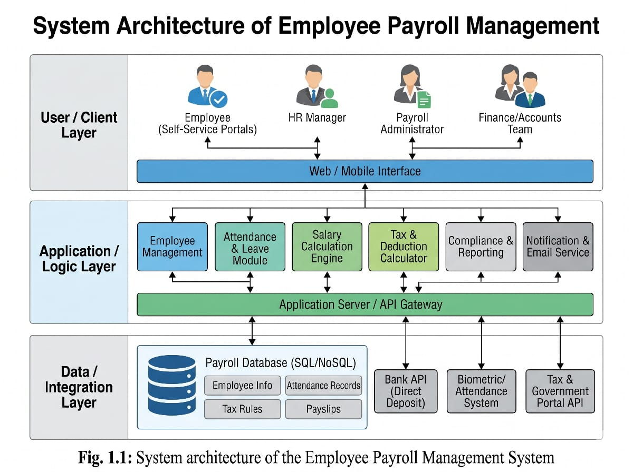

Figure 1.1 – Suggested system architecture: User  Main Menu  Employee Management / Attendance Management / Salary Management / Payroll Processing / Salary Slip / Report  Console Results. Draw this diagram in your report or insert a screenshot of the diagram.

1.4.2 Algorithm
1.Start the program.
2.Initialise the employee array and set the employee count to zero.
3.Display the main menu with all available operations.
4.Read the user's choice.
5.If the user selects Add Employee, check the capacity and ID, collect the details, store the
new object, and increase the employee count.
6.If Display Employees is selected, loop through the active records and display each employee's details.
7.If Search Employee is selected, read an Employee ID and search for a matching record.
8.If Update Employee is selected, locate the matching ID and change the requested fields.
9.If Delete Employee is selected, locate the ID, remove the record, shift later records if an
array is used, and reduce the employee count.
10.If Attendance Management is selected, enter the employee's working hours and leave status.
11.If Salary Management is selected, calculate gross salary and net salary using the stored salary.
12.If Payroll Processing, Salary Slip, or Report is selected, display the corresponding salary .
13.If the user has not selected Exit, return to the main menu.
14.If Exit is selected, terminate the program.

1.4.3 Salary Calculation
The salary calculation is based on the values entered for each employee. Gross salary represents the total before deductions. Net salary represents the amount remaining after deductions have been subtracted.
Gross Salary = Basic Salary + Allowance + Bonus Net Salary = Gross Salary  Deduction

CHAPTER 2
PROJECT IMPLEMENTATION
2.1. OOP Concepts Used for implementation
Object-Oriented Programming organises a program around classes and objects. It is useful when an application needs to represent real-world entities and the operations associated with them. In this project, an employee is represented as an object, and the Employee class defines the fields and functions shared by employee records.

Class
A class is a user-defined type that acts as a blueprint for objects. The Employee class defines the employee ID, name, department, salary components, working hours, and leave status. It also groups the functions that add, update, search, or display employee-related information. This makes the code easier to organise than maintaining separate variables for each employee.

Object
An object is an instance of a class. Each Employee object represents one employee and holds its own values. When an array of Employee objects is used, the program can maintain several employee records using the same class definition. A change to one array element affects that employee's record rather than every employee.

Encapsulation
Encapsulation means grouping data and the functions that operate on it inside a class. The Employee class keeps employee information and payroll-related operations together. This gives the program a clear structure and makes it easier to locate the code responsible for a particular task. The current implementation uses public members for simplicity; access modifiers can be strengthened in a future version.

Constructor
A constructor is a special member function that is called when an object is created. The Employee constructor initialises fields to default values such as zero for numeric salary fields and a default description for leave status. Initialising fields helps prevent the program from relying on uninitialised values before data is entered.

Member Functions
Member functions define the operations that an Employee object or the application can perform. Examples include addEmployee(), updateEmployee(), attendanceManagement(), calculateGrossSalary(), calculateNetSalary(), salaryManagement(), processPayroll(), generateSalarySlip(), and generateReport(). Dividing tasks into functions improves readability and allows the same operation to be called from different menu options.

Array of Objects
An array of objects stores multiple Employee objects under one array name. The program uses a loop to check each active object when searching for an Employee ID. When an employee is deleted, the remaining entries can be shifted to keep the active records together. A fixed-size array is simple for a beginner project, although a vector or database would be more flexible for larger applications.

Loops
Loops repeat a set of instructions. A loop can display all employee records or search through the array until the matching ID is found. A menu loop allows the program to continue accepting choices until the user selects Exit.
Loops reduce duplicated code and are especially useful when the number of employees changes during execution.

Conditional Statements
Conditional statements allow the program to make decisions. They are used to check menu choices, determine whether an Employee ID exists, reject duplicate IDs, and display an appropriate message when a record is not found. Correct conditions are important because they help ensure that update and delete operations act on the intended employee.

Concept | Project example | Purpose
Class | Employee | Defines data fields and related functions.
Objects | Individual employee entries | Represents separate employees.
Encapsulation | Employee data and operations grouped together | Organises related functionality.
Constructor | Employee() | Initialises fields with default values.
Member functions | addEmployee(), updateEmployee() | Performs specific operations.
Array of objects | employees[] | Maintains multiple records.
Loops | Display and search loops | Processes multiple employee records.
Conditions | Menu and Employee ID checks | Controls program decisions.

How OOP Supports the Project
The class-based design makes the relationship between employee data and payroll operations clear. If an additional field is required, it can be added to the class and then used by the relevant functions. Functions also separate the program into manageable tasks. These design choices support learning, debugging, and future extension, although permanent storage and advanced security require additional implementation.

2.2. Code
The system is implemented as a menu-driven C++ console program. The standard input/output library is used for reading and displaying information, the string library supports names and department text, and the formatting library can be used to align tabular output. The Employee class defines the data stored for each employee and the functions used by the application.
#include <iostream>
#include <string>
#include <iomanip>
using namespace std;

class Employee
{
public:
int id;
string name, department, leaveStatus;
float basic, bonus, deduction, workingHours;

Employee()
{
id = 0;
name = "";
department = "";
basic = bonus = deduction = workingHours = 0;
leaveStatus = "Not Recorded";
}

// Employee Management: Update basic salary only
void updateEmployee()
{
cout << "\nEmployee ID: " << id << endl;
cout << "Employee Name: " << name << endl;
cout << "Current Basic Salary: " << basic << endl;

cout << "Enter New Basic Salary: ";
cin >> basic;

cout << "\nBasic salary updated successfully!\n";
cout << "Employee record has not been deleted.\n";
}

// Attendance Management
void attendanceManagement()
{
cout << "\nEnter Working Hours: ";
cin >> workingHours;

cin.ignore(10000, '\n');
cout << "Enter Leave Status: ";
getline(cin, leaveStatus);

cout << "\nAttendance recorded successfully!\n";
}

// Salary Management
float calculateGrossSalary()
{
return basic + bonus;
}

float calculateNetSalary()
{
return calculateGrossSalary() - deduction;
}

void salaryManagement()
{
cout << "\n========== SALARY DETAILS ==========\n";
cout << "Employee ID : " << id << endl;
cout << "Name : " << name << endl;
cout << "Basic Salary : " << basic << endl;
cout << "Bonus : " << bonus << endl;
cout << "Deduction : " << deduction << endl;
cout << "Gross Salary : " << calculateGrossSalary() << endl;
cout << "Net Salary : " << calculateNetSalary() << endl;
}

// Payroll Processing
void processPayroll()
{
cout << "\n========== PAYROLL PROCESSING ==========\n";
cout << "Employee ID : " << id << endl;
cout << "Employee Name: " << name << endl;
cout << "Department : " << department << endl;
cout << "Gross Salary : " << calculateGrossSalary() << endl;
cout << "Net Salary : " << calculateNetSalary() << endl;
cout << "\nPayroll processed successfully!\n";
}

// Salary Slip
void generateSalarySlip()
{
cout << "\n========== SALARY SLIP ==========\n";
cout << "Employee ID : " << id << endl;
cout << "Name : " << name << endl;
cout << "Department : " << department << endl;
cout << "Basic Salary : " << basic << endl;
cout << "Bonus : " << bonus << endl;
cout << "Deduction : " << deduction << endl;
cout << "Gross Salary : " << calculateGrossSalary() << endl;
cout << "Net Salary : " << calculateNetSalary() << endl;
cout << "=================================\n";
}

// Report Generation
void generateReport()
{
cout << "\n========== PAYROLL REPORT ==========\n";
cout << "Employee ID : " << id << endl;
cout << "Name : " << name << endl;
cout << "Department : " << department << endl;
cout << "Working Hours : " << workingHours << endl;
cout << "Leave Status : " << leaveStatus << endl;
cout << "Basic Salary : " << basic << endl;
cout << "Bonus : " << bonus << endl;
cout << "Deduction : " << deduction << endl;
cout << "Gross Salary : " << calculateGrossSalary() << endl;
cout << "Net Salary : " << calculateNetSalary() << endl;
cout << "====================================\n";
}
};

int main()
{
const int MAX_EMPLOYEES = 100;
Employee employees[MAX_EMPLOYEES];

int employeeCount = 0;
int choice, searchID;

do
{
cout << "\n\n====================================\n";
cout << " EMPLOYEE PAYROLL SYSTEM\n";
cout << "====================================\n";
cout << "1. Add Employee\n";
cout << "2. Display All Employees\n";
cout << "3. Search Employee\n";
cout << "4. Update Basic Salary\n";
cout << "5. Delete Employee\n";
cout << "6. Attendance Management\n";
cout << "7. Salary Management\n";
cout << "8. Payroll Processing\n";
cout << "9. Generate Salary Slip\n";
cout << "10. Generate Payroll Report\n";
cout << "11. Exit\n";
cout << "Enter your choice: ";
cin >> choice;

// 1. Add Employee
if (choice == 1)
{
if (employeeCount >= MAX_EMPLOYEES)
{
cout << "\nEmployee storage is full!\n";
continue;
}

cout << "Enter Employee ID: ";
cin >> searchID;

bool duplicate = false;

for (int i = 0; i < employeeCount; i++)
{
if (employees[i].id == searchID)
{
duplicate = true;
break;
}
}

if (duplicate)
{
cout << "\nEmployee ID already exists!\n";
continue;
}

Employee &emp = employees[employeeCount];
emp.id = searchID;

cin.ignore(10000, '\n');

cout << "Enter Employee Name: ";
getline(cin, emp.name);

cout << "Enter Department: ";
getline(cin, emp.department);

cout << "Enter Basic Salary: ";
cin >> emp.basic;
cout << "Enter Bonus: ";
cin >> emp.bonus;
cout << "Enter Deduction: ";
cin >> emp.deduction;

employeeCount++;
cout << "\nEmployee added successfully!\n";
}

// 2. Display All Employees
else if (choice == 2)
{
if (employeeCount == 0)
{
cout << "\nNo employee records found.\n";
}
else
{
cout << "\n========== ALL EMPLOYEES ==========\n";

cout << left
<< setw(10) << "ID"
<< setw(22) << "Name"
<< setw(20) << "Department"
<< setw(15) << "Net Salary" << endl;

for (int i = 0; i < employeeCount; i++)
{
cout << left
<< setw(10) << employees[i].id
<< setw(22) << employees[i].name
<< setw(20) << employees[i].department
<< setw(15) << fixed << setprecision(2)
<< employees[i].calculateNetSalary()
<< endl;
}
}
}

// Options 3 to 10 require an existing employee
else if (choice >= 3 && choice <= 10)
{
if (employeeCount == 0)
{
cout << "\nNo employee records found.\n";
continue;
}

cout << "Enter Employee ID: ";
cin >> searchID;

int index = -1;

for (int i = 0; i < employeeCount; i++)
{
if (employees[i].id == searchID)
{
index = i;
break;
}
}

if (index == -1)
{
cout << "\nEmployee not found!\n";
continue;
}

switch (choice)
{
// 3. Search Employee
case 3:
cout << "\nEmployee ID : " << employees[index].id << endl;
cout << "Name : " << employees[index].name << endl;
cout << "Department : " << employees[index].department << endl;
cout << "Basic Salary : " << employees[index].basic << endl;
cout << "Bonus : " << employees[index].bonus << endl;
cout << "Deduction : " << employees[index].deduction << endl;
cout << "Gross Salary : "
<< employees[index].calculateGrossSalary() << endl;
cout << "Net Salary : "
<< employees[index].calculateNetSalary() << endl;
cout << "Working Hours : " << employees[index].workingHours << endl;
cout << "Leave Status : " << employees[index].leaveStatus << endl;
break;

// 4. Update Basic Salary
case 4:
employees[index].updateEmployee();
break;

// 5. Delete Employee
case 5:
for (int j = index; j < employeeCount - 1; j++)
{
employees[j] = employees[j + 1];
}
employeeCount--;
cout << "\nEmployee deleted successfully!\n";
break;

// 6. Attendance Management
case 6:
employees[index].attendanceManagement();
break;

// 7. Salary Management
case 7:
employees[index].salaryManagement();
break;

// 8. Payroll Processing
case 8:
employees[index].processPayroll();
break;

// 9. Salary Slip
case 9:
employees[index].generateSalarySlip();
break;

// 10. Payroll Report
case 10:
employees[index].generateReport();
break;
}
}

// 11. Exit
else if (choice == 11)
{
cout << "\nThank you for using Employee Payroll System!\n";
}
else
{
cout << "\nInvalid choice! Enter a number from 1 to 11.\n";
}

} while (choice != 11);

return 0;
}

2.3. Output Screens
Output screenshots provide visual evidence that the program compiles, accepts input, performs the selected operation, and displays the expected result. Each screenshot should be captured from the actual program after running it. Use a clear font size and include the menu or relevant output in the image. The descriptions below can be placed under the corresponding screenshots.

Figure 2.1: Main Menu
The main menu is the entry point to the system. It lists the available actions, such as adding, displaying, searching, updating, and deleting employee records, managing attendance, calculating salary, processing payroll, generating a salary slip, generating a report, and exiting. This menu-driven structure makes the application easy to navigate for a user who is familiar with basic keyboard input.
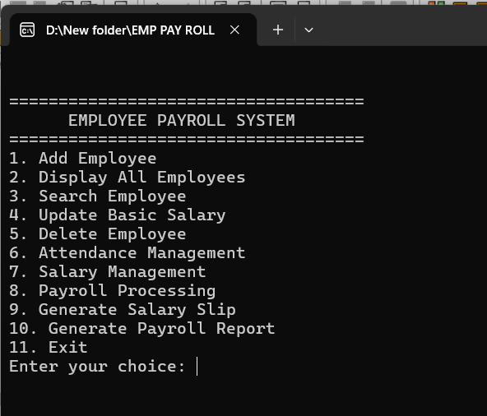

Figure 2.2: Add Employee and Display Employees
The Add Employee screen shows the input of an employee's ID, name, department, and salary components. After the details are accepted, the display option lists the active employee records. This output demonstrates that the program can maintain multiple records during execution and present them in an organised way. If the program includes duplicate-ID validation, the corresponding message may also be shown as a separate screenshot.
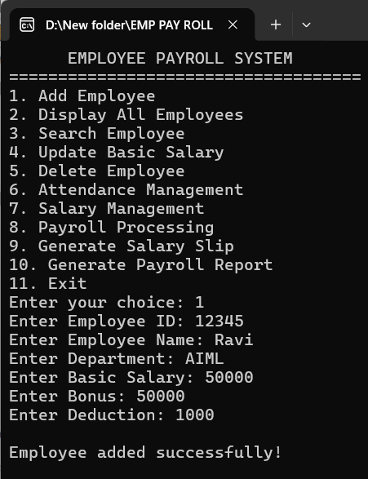

Figure 2.3: Search and Update Employee
The search screen asks for an Employee ID and displays the matching record. The update screen uses the ID to identify which employee should be changed. To demonstrate successful updating, capture the original record, perform the update, and then search or display the same ID again to show the revised information. This confirms that the program updates the intended object rather than an unrelated employee.
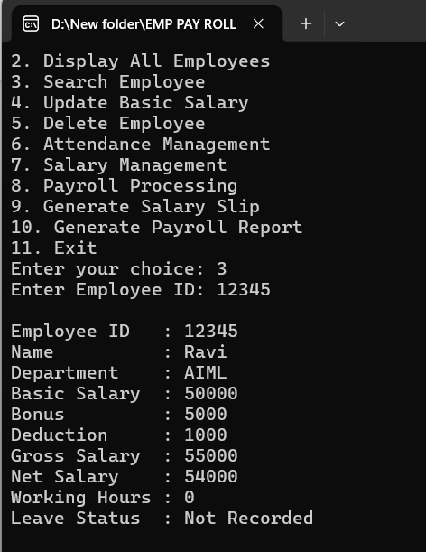\

Figure 2.4: Delete Employee
The delete screen demonstrates removal of an employee record. Enter the ID of an existing employee, confirm the removal message, and display the records again. The deleted ID should no longer appear in the active list. A separate screenshot can show the response when the user attempts to delete an ID that does not exist.
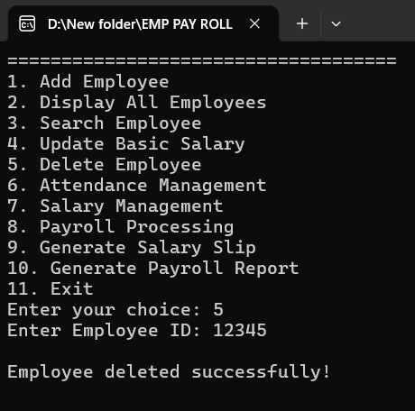

Figure 2.5: Attendance and Salary Management
The attendance screen displays the entry of working hours and leave status. The salary management screen displays the salary components and the calculated gross and net amounts. Use an example with simple values so the displayed totals can be checked against the formulas. The screenshot should show the values entered and the resulting calculation clearly.
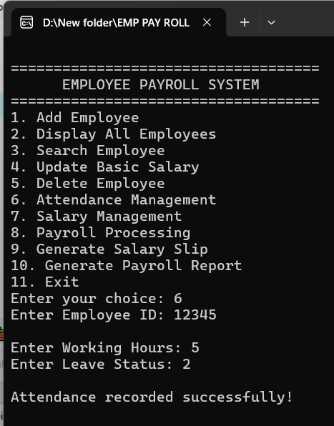

Figure 2.6: Salary Slip and Payroll Report
The salary slip screen presents an individual employee's details and salary breakdown. The payroll report displays the available employee records and their salary totals. These outputs demonstrate the reporting functions of the application and help the user review salary information in a structured format.
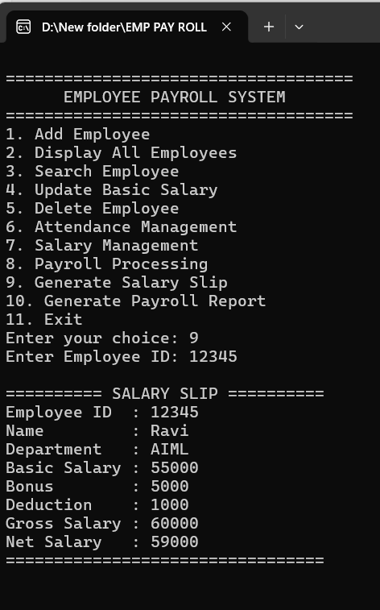

Suggested Test Cases

Test ID | Input / action | Expected result
TC1 | Add a new employee with a unique ID | Record is added and employee count increases.
TC2 | Add an employee using an existing ID | Duplicate ID is rejected if duplicate validation is implemented.
TC3 | Display employees | All active employee records are shown.
TC4 | Search using a valid ID | Matching employee details are displayed.
TC5 | Search using an unknown ID | A not-found message is displayed.
TC6 | Update a valid ID | Only the matching employee record is modified.
TC7 | Delete a valid ID | The selected record is removed from the active list.
TC8 | Enter attendance information | Working hours and leave status are stored for the selected employee.
TC9 | Calculate salary | Gross and net salary match the specified formulas.
TC10 | Generate salary slip | The selected employee's salary details are displayed.
TC11 | Generate report | The active employee salary information is listed.
TC12 | Select Exit | The application terminates.

These test cases are suggestions for evaluating the program. Record a test as successful only after running the corresponding operation and checking the actual output. Add screenshots of important tests to strengthen the implementation section.

CHAPTER 3
CONCLUSION & FUTURE SCOPE

3.1 Conclusion
The Employee Payroll Management System was designed as a menu-driven C++ application to organise employee records and support basic payroll activities. It provides operations for adding, displaying, searching, updating, and deleting employee information. The program also includes attendance-related entry, salary calculations, payroll processing, salary-slip display, and payroll reporting.
The project demonstrates the application of Object-Oriented Programming concepts to a practical problem. The Employee class groups the data and functions related to an employee, constructors initialise values, member functions perform individual tasks, and an array of objects allows multiple employee records to be managed during execution. Loops and conditional statements support searching, displaying, and selecting menu operations.
The salary calculations use a consistent formula: gross salary is the sum of basic salary, allowance, and bonus, while net salary is calculated by subtracting deduction from gross salary. Employee ID-based searching helps the user identify the intended record when performing update and delete operations. These features reduce repetitive manual work and make the program's operations easier to follow.
The project also provided practical experience in planning program modules, writing C++ functions, handling input, testing different menu options, and preparing technical documentation. The current version is a learning prototype rather than a complete commercial payroll product. Employee information is stored in memory and is not retained after the program closes. Additional storage, security, and payroll rules would be required before using a system of this type in an organisation.

Future Scope
1. Database Integration: Store employee details, salary records, and attendance information permanently using a database such as MySQL.
2. Login and Authentication: Provide secure login facilities for administrators, payroll managers, and employees with different access permissions.
3. Automated Payroll Calculation: Automate monthly salary calculations based on basic salary, bonuses, deductions, and attendance records.
4. Attendance and Leave Management: Integrate attendance tracking and leave records with payroll calculations.
5. Digital Salary Slips: Generate downloadable and printable salary slips for employees.
6. Report Generation: Generate monthly salary reports, employee records, attendance reports, and payroll summaries.
7. Employee Self-Service: Allow employees to view their personal details, salary information, attendance, and salary slips.
8. Web-Based Application: Convert the C++ console application into a web-based system so users can access it through a browser.
9. Data Backup and Recovery: Provide automatic backups and recovery options to protect important payroll information.
10. Tax and Compliance Management: Include applicable tax calculations and statutory deductions according to current rules and regulations.

